Please be sure to have completed the “Author Information Form” at the last page of the Template
PLEASE LEAVE THE HEADER AND FOOTER AREAS AS THEY ARE
A SWOT Analysis of Hospital Management
(Title in English; Centered, Bold, Title Case Heading ( bold with first letters of the words capital, Times New Roman 12 Font)
Halil İ. Sertel & Nazlı S. White
Abstract
A summary not exceeding 250 words should be given. No other published work should be cited in the abstract. Paragraph spacing in the abstracts should be written with single line spacing with zero (0) before and then eight pt (8 pt).space after the paragraph. It should be written in plain text form (not italic) and justified. Do not use a second paragraf. The abstract addresses the following (usually 1–2 sentences per topic): Key aspects of the literature review, problem under investigation or research question(s), clearly stated hypothesis or hypotheses, methods used (including brief descriptions of the study design, sample, and sample size), study results, implications (i.e., why this study is important, applications of the results or findings).
Keywords: hospital management, SWOT analysis, strength, weakness, opportunity, threat (There should be 3–6 keywords appropriate to the content of the article) lowercased (but capitalize proper nouns)
JEL Codes: M10,M21,C44, Z00 (There should be 3–6 JEL codes)

LÜTFEN ÜST VE ALT BİLGİ KISIMLARINI OLDUĞU GİBİ BIRAKINIZ
Hastane Yönetim Süreci için SWOT Analizi
(Türkçe Başlık Ortalanmış, Birinci Düzey Başlık (kelimlerin sadece ilk harfleri büyük ve kalın Times New Roman 12 punto yazılmalıdır)
Halil İ. Sertel & Nazlı S. White
Öz
250 kelimeyi geçmeyen bir özet verilmelidir. Özet kısmında başka bir yayınlanmış çalışmaya atıf yapılmamalıdır. Özetlerde paragraf aralığı önce sıfır(0) sonra sekiz nk(8nk) satır aralığı tek ve iki yanayaslı yazılmalıdır. Düz yazı formunda(italik değil) yazılmalıdır Paragraf düzenleme görseli aşağıda verilmiştir. İkinci bir paragraf kullanmayın. Özet aşağıdakileri içerir. (genellikle konu başına 1-2 cümle): Literatür taramasının temel sonuçları, araştırılan problem veya araştırma soru(lar)ı, açıkça ifade edilmiş hipotez veya hipotezler, kullanılan yöntemler (çalışma tasarımı, örnek ve örneklem büyüklüğü ile ilgili kısa açıklamalar), çalışma sonuçları, çıkarımlar (yani, bu çalışmanın neden önemli olduğu, sonuçların veya bulguların uygulamaları).
Anahtar Kelimeler: hastane yönetimi, SWOT analizi, güçlü yön, zayıf yön, fırsat, tehdit (Özetlerin altında makalenin içeriğine uygun 3–6 adet anahtar kelime yer almalıdır). küçük harfle (ancak özel isimleri büyük harfle yazın)
JEL Kodlar: M10,M21,C44, Z00 (Özetlerin altında makalenin içeriğine uygun 3–6 adet JEL kodları yer almalıdır).

Each manuscript should be at least 4000 words and at most 30 pages long, excluding abstracts and bibliography. Manuscripts must be written in Microsoft Office Word 2007 or later.
Headings in Main Body of the Text
(First Level Headings: Centered, Bold, First Letters Capitalized)
The paragraph below the first-level heading must start one tab from the left.

(Second Level Headings: Left Aligned, Bold, First Letters Capitalized)
The paragraph below the second level heading must start one tab from the left.

(Third Level Headings: Left Aligned, Bold, Italic,First Letters Capitalized)
The paragraph below the third-level heading must start one tab from the left.

(Fourth Level Headings: First Line One tab from the left, Bold, First Letters Capitalized, Ending with a Period. The text starts on the same line and continues as a normal paragraph.

(Fifth Level Headings: First Line One tab from the left, Bold, Italic, First Letters Capitalized, Ending with a Period. The text starts on the same line and continues as a regular paragraph.

Heading levels should follow each other hierarchically. For example, after the first-level heading, do not use a third-level heading without using a second-level heading.
For information on APA STYLE Version 7 title levels, see the relevant page: https://apastyle.apa.org/style-grammar-guidelines/paper-format/headings

Introduction (First Level Heading)
(First Level Heading should be written in bold and centered with only the first letters capitalized. Times New Roman Font 12 points, bold). Only the first letters of the words should be capitalized, the other letters should be lowercase.
The paragraph under the Introduction must start one tab from the left side.
Text main body: Times New Roman, 12 font, single spacing, justified.
Paragraph Order: Paragraphs should start one tab in from the left, no extra space should be left before the paragraf and 8pt of space should be left after the paragraph.
The manuscript should be written in A4 size paper, page margins should be set to 2.5 cm from each side (top, bottom, right, left 2.5 cm). The format of this file is adjusted accordingly. Please do not change it.
Literature Review (First Level Heading)
It is not obligatory to follow the subject headings given here, and it is recommended that the authors make the changes they consider to be appropriate.
Method (First Level Heading)
Methodus in praxi electa fundata est in principio, quod medii et inferiores administratores ac negotiatores operarii in hospitali monitore laborantes mutationes fiendas in consumables medicorum intra ambitum qualitatis cycli, eas si non est problema, considera. si queritur et caveas.
“Ethics Committee Permission obligation has been introduced in every………. conducted after 2020. However, since this study was conducted before 2020, ethics committee approval was not obtained”.
OR
“Permission from an Ethics Committee from a university is required in every ………. conducted after 2020. Since a(n) ……… was used in this study as a data collection method, the permission has been obtained from Ethics Committee of the ………… University with a decision on the date of DD.MM.YYYY and document number………...”
Select the method you used in your research from the list below and fill in the first two blanks with it:
Any kind of research: conducted with qualitative or quantitative approaches that requires data collection from participants using survey, interview, focus group interview, observation, experiment, conversation.
Data Set Second Level Headings should be Left Aligned, Bold and First Letters Capitalized.
Finis huius recensionis erit tam qualitatem quam parabilem materias, quae in foro inveniri possunt, determinare voluntas tua. The first paragraph after the second level heading should start one tab from the left.
Demographics (Third Level Headings Should Be Left Aligned, Bold, Italicized and First Letters Capitalized)
Omnes participes qui rogationum impleverunt in nosocomio tempore applicationis functionis laborabant. Interrogationes collectae et responsa ad singulas quaestiones singulatim perpensa sunt. The first paragraph after the third level heading should start one tab from the left.
Gender. Ex ordine proventuum Mann-Whitney U experimenti in hac tabula, ostenditur mares nutrices altiorem perceptionem instrumentorum electronicarum quam feminae nutrices habere. Alia inventio ex hac tabula colligitur quod participes, qui satisfaciunt de operibus suis, majorem habent perceptionem amoris patientis, quam illi qui displicent. (Fourth Level Headings First Line One tab from the left, Bold, First Letter Capitalized and Ended with a Period.) The first paragraph after the fourth level heading should start on the same line and continue as a normal paragraph.
Cum hoc, propter probationis independentis specimen applicatum satisfactionis officium variae et condiciones corporis variabiles (t=-3.553, sig.= .001), observatum est peraeque significantem relationem inter condiciones physicas esse. et satisfactio officium, cum 5% gradu significat. Cum corporis conditionum emendatione, exempli gratia, ad solvendas quaestiones in numero personarum, vias sternens ad onus laboris minuendum et ad illum finem ampliora officia praebendo, campestris satisfactionis.augeri potest.
Change of Response Difference by Gender. Ex analysi inter variabiles institutionis personarum et corporis condiciones, relatio significativa et positiva inter has duas variabiles deprehensa est. Negatio et significativa relatio observata est inter apparatum electronicum perceptio praefectorum participum et aegri ordinationes et informationes patientis. . (Fifth Level Headings First Line One tab from the left, Bold, Italic, First Letters Capitalized and Ended with a Period. The first paragraph after the fifth level heading should start on the same line and continue as a normal paragraph.
Expertus statisticus et ordines consecuti sunt ex testo Mann-Whitney U, inter varia armorum electronicorum et variabilium genera et variabilis amoris patientis et variabilis satisfactionis operae provisa sunt.

Paragraph editing image is given below.

Explanations on Citations in the Main Text Body:

Citing an article in the text
In the APA 7 reference system, authors can make two separate styles of references, both acceptable, in their articles.
A parenthetical citation should be given as (Devanny & Gearson, 2021) in parenthesis. The “&” sign should be used in place of the word “and”.For example:
A fragmented domestic agenda won't produce the strength and cohesion of thought needed to play an active role in the world (Devanny & Gearson, 2021).
In the Narrative citation method, the surname(s) of the directly cited author(s) appears in the text.Year of publication is added in parentheses after the author's name and the sentence continues. It should be given as Devanny and Gearson (2021) in the in-text narration; the word “and” should be used instead of the “&” sign. For example:
As Devanny and Gearson (2021) argue, the UK will not be able to realise its 'Global Britain' ambitions unless it first addresses domestic issues as well as those linked to its current and potential relations with Europe.

Citing a book in the text
If there are two authors:
It should be given as (Devanny & Gearson, 2021) in parenthesis. The “&” sign should be used in place of the word “and”.For example:
A fragmented domestic agenda won't produce the strength and cohesion of thought needed to play an active role in the world (Devanny & Gearson, 2021).
It should be given as Devanny and Gearson (2021) in the in-text narration; The word “and” should be used instead of the “&” sign. For example:
As Devanny and Gearson (2021) argue, the UK will not be able to realise its 'Global Britain' ambitions unless it first addresses domestic issues as well as those linked to its current and potential relations with Europe.

If there are three or more authors

It should be given as (Hanley et al., 2019) in Parenthetical citation

It should be given as Hanley et al. (2008) in Narrative citation
Display of an article in the References
In case of article citation, the first letter of the first word in the article title should be capitalized, the remaining letters of the word and other words should be written in lower case. Afterwards, the journal name should start with a capital letter and be written in italics. Journal volume number should be italicized but the issue number should be plain in parenthesis. Page range should be given, followed by a dot. The article doi number, if any, should be given lastly.
Valentine, S. & Fleischman, G. (2008). Ethics programs, perceived corporate social responsibility and job satisfaction. Journal of Business Ethics, 77(2), 159-172. https://doi.org/10.1007/s10551-006-9306-z

Representation of a book in the References
The title of the book should be italicized and the first letter of the first word in the title should be capitalized, the remaining letters of the word and other words should be in lowercase. The title of the book should have a dot at the beginning and end, and then the name of the publisher should be given with a plain and capital letter.
Hanley, N., Shogren, J., & White, B. (2019). Introduction to environmental economics. Oxford University Press. (Only the publisher should be given, but not the place of publication).
7th edition published by the American Psychological Association (APA) should be followed.
For more information about APASTYLE 7 th on cases not mentioned above, you can refer to the following page:
https://apastyle.apa.org/style-grammar-guidelines/references/examples/

Use of Footnotes
Footnotes that can only be used to provide explanatory information. They should be written in 10 font and single line spacing.

Quotations:
Direct quotations of less than 40 words should be shown in quotation marks and in accordance with the format used throughout the article. For example:
Shared values, fundamental to British national identity, on the other hand, consist of a “commitment to universal human rights, the rule of law, free speech and fairness and equality” (Cabinet Office, 2021, p. 13).
Direct quotations which include more than 40 words should be shown as a block, without quotation marks, indented 1.25 cm from the left.
Parenthetical citation example:
Security concerns and trade relations have been central in the UK- China bilateral relations for decades and so will be the next decade. Integrated Review points out that:
China’s growing international stature is by far the most significant geopolitical factor in the world today, with major implications for British values and interests and for the structure and shape of the international order. The fact that China is an authoritarian state, with different values to ours, presents challenges for the UK and our allies. China will contribute more to global growth than any other country in the next decade with benefits to the global economy. China and the UK both benefit from bilateral trade and investment, but China also presents the biggest state-based threat to the UK’s economic security. (Cabinet Office, 2021, p. 62)
Narrative citation example:
Introduction of artificial intelligence into finance seems to have changed some traditional approaches. Juan Coffi and Babu George (2022) states:
Robo-advisors definitely have the potential to positively disrupt the financial advising and investment market. Wealth management firms have learned to incorporate these tools in a collaborative rather than competitive way. While some have externalized them, many companies have even learned how to build them in-house. (p.266)

For information about APA STYLE version 7 Quotations, please refer to the relevant page. https://apastyle.apa.org/style-grammar-guidelines/citations/quotations

Explanation about Tables and Figures to be included in the full text
The main body of tables and figures should be written in Times New Roman, 10 fonts (not italic). Tables annd figures should be placed in the text aligned to the left.
If Tables or figures are not suitable for inclusion in the text, they should be placed at the end of the text and immediately after the References, in “Appendix”.
The display should follow the following order.
“Table”/ “Figure” followed by sequence number
Heading of the Table/Figure
Table/Figure image
Note.
Please check the sample images below.

Figure 1 (justified left, Times New Roman 12 font, plain text, bold)
Agricultural Sector Value Added, 1995-2005 (%) (justified left, Times New Roman 12 font, italic)
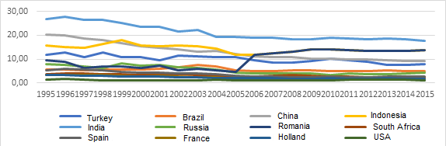
Note. Calculated using OECD Input-Output Tables.

Figure 2 (justified left, Times New Roman 12 font , plain text, bold)
Confirmator Primarius Factor Analysis (justified left, Times New Roman 12 font, italic)
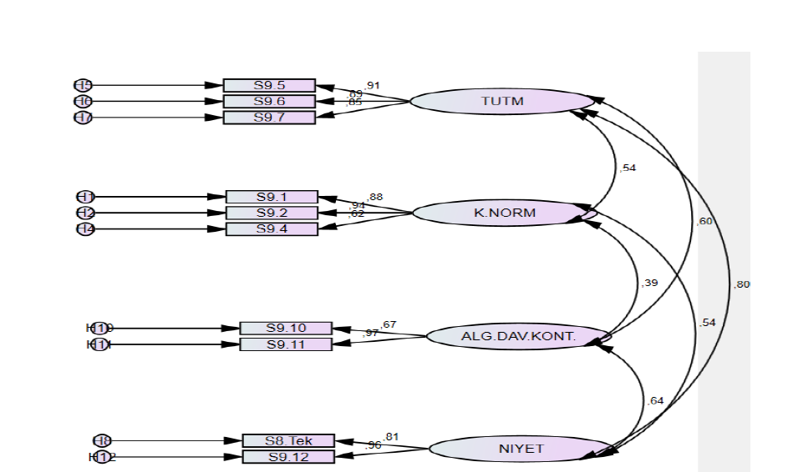

Note.Created by the author.
Figure 3 (justified left, Times New Roman 12 font, plain text, bold)
Rationis Exemplar Studiorum (justified left, Times New Roman 12 font, italic)

Note. Created by the author.
Explanations, including the sources, should be given below the figure/table as a “Note”. It should be written in Times New Roman, 12 font. A single dot should be placed after the word “Note”.

Table 1 (justified left, Times New Roman 12 font, plain text, bold)
Share of the Value Added of Final Demand in Agricultural Sector in GDP (%) (justified left, Times New Roman 12 font, italic)

Country | Final Demand | 1995 | 2000 | 2001 | 2002 | 2005 | 2008 | 2009 | 2010 | 2015
Turkey | Domestic | 11.01 | 10.15 | 8.48 | 10.36 | 9.72 | 7.70 | 8.12 | 9.23 | 6.89
 | Abroad | 0.87 | 0.70 | 1.00 | 0.97 | 1.01 | 0.81 | 1.02 | 1.05 | 0.94
Brazil | Domestic | 5.10 | 4.89 | 4.90 | 5.26 | 3.83 | 3.89 | 3.89 | 3.72 | 3.34
 | Abroad | 0.63 | 0.82 | 1.16 | 1.43 | 1.53 | 1.44 | 1.28 | 1.13 | 1.69
China | Domestic | 18.59 | 14.06 | 13.45 | 12.74 | 10.53 | 9.42 | 9.28 | 9.08 | 8.29
 | Abroad | 1.74 | 1.33 | 1.19 | 1.21 | 1.59 | 1.31 | 1.05 | 1.01 | 0.89
France | Domestic | 2.57 | 2.15 | 2.19 | 2.07 | 1.36 | 1.16 | 1.04 | 1.24 | 1.19
 | Abroad | 0.76 | 0.69 | 0.66 | 0.64 | 0.46 | 0.48 | 0.38 | 0.49 | 0.56
Holland | Domestic | 1.20 | 0.98 | 1.07 | 0.94 | 0.74 | 0.68 | 0.66 | 0.74 | 0.64
 | Abroad | 2.27 | 1.65 | 1.49 | 1.40 | 1.26 | 1.09 | 1.00 | 1.17 | 1.17
USA | Domestic | 1.03 | 0.89 | 0.89 | 0.79 | 1.02 | 0.92 | 0.87 | 0.94 | 0.90
 | Abroad | 0.26 | 0.16 | 0.16 | 0.14 | 0.16 | 0.23 | 0.19 | 0.23 | 0.20
Note. Calculated using OECD Input-Output Tables.
Explanations, including the sources, should be given below the figure/table as a “Note”. It should be written in Times New Roman, 12 font. A single dot should be placed after the word “Note”.
Tables should be placed left-justified in the text and numbered sequentially (Table 1, Table 2 etc.).
Figures should be placed left-justified in the text and numbered sequentially (Figure 1, Figure 2 etc.).
If there are sources of tables or figures, they should be given in “Note”, according to the in-text citation rules. Times New Roman should be written in 12 font size (not italic).
For more sample Table and Figure displays;
See: https://apastyle.apa.org/style-grammar-guidelines/tables-figures

Authors must add a page break by using the "Insert>Page Break" menu before every case they want to have at the beginning of the page (for example, before tables that should not be divided).

Explanation About Mathematical and Statistical Symbols and Equations
If the text contains mathematical and statistical symbols, they should be prepared using the Microsoft Office Equation Editor (Insert>Equation).
If there are equations, they should be numbered starting from 1. Equation sequence numbers should be placed in parenthesis to the right of the equation line. An extra space should be left above and below the equation in question.

 | $$μ(x|(\tilde{M})\left\{\begin{aligned}\begin{matrix}0 & x<1, \\ (x-l)/(m-l) & l≤x≤m,\end{matrix} \\ \begin{matrix}(u-x)/(u-m) & m≤x≤u, \\ 1 & x>u.\end{matrix}\end{aligned}\right.$$ | (1)
Hypotheses, if used, should be written as follows.
H1: Habitus insignem effectum habet in intentione ad mores.
H2: Percepta morum imperium signanter afficit intentionem morum.
H3: Normae personales significanter se gerendi intentionem afficiunt.
H4: Est relatio inter humanitatis imperium et normas personales percipi.
Conclusion
(First Level Headings: Centered, Bold, First Letters Capitalized, Times New Roman 12 font). It is very important to have this section in your article. Please be sure to follow the format as explained.

References (First Level Heading)
At the end of the text, there should be a “References” section which will be arranged alphabetically according to the surnames of the authors.
Attention: The References Section should not start from where the text of the study ends, it should go to the next page. A page break before References (using “Insert>Page Break” menu option).should be used.
References text (Times New Roman Font, 12 font, Normal). Special hanging 1.25 should be chosen. References line spacing should be 8 pt.
Its image is given below.

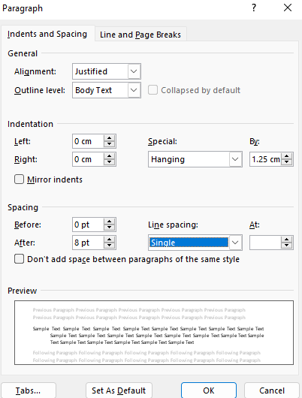

7th edition published by the American Psychological Association (APA) should be followed.
There is no need to group the references as books, articles, other internet resources etc.
The references should include only the publications used in the manuscript.
Ahmad, A. & Thyagaraj, K. S. (2015), Consumer’s intention to purchase green brands: The roles of environmental concern, environmental knowledge and self-expressive benefits, Current World Environment, 10(3), 879-889. (Article example)
Valentine, S. & Fleischman, G. (2008). Ethics programs, perceived corporate social responsibility and job satisfaction. Journal of Business Ethics, 77(2), 159-172. https://doi.org/10.1007/s10551-006-9306-z (Example of article with DOI number)
Hanley, N., Shogren, J., & White, B. (2019). Introduction to environmental economics. Oxford University Press. (Book example)
U.S. Census Bureau. (n.d.). Turkey. U.S. Department of Commerce. Retrieved May 5, 2023, from https://www.census.gov/popclock/world/tu (internet resource example)
Türkiye İstatistik Kurumu (t.y.). SDDS Veri Kategorileri ve Bileşenleri. Mayıs 05, 2023 de https://data.tuik.gov.tr/Turcat den erişildi (internet resource example)
Ziady H. (2023, May 4) European Central Bank hikes rates by a quarter-percentage point. CNN. https://edition.cnn.com/2023/05/04/economy/european-central-bank-interest-rates/index.html (internet resource example)
Eğilmez M. (2012, Mayıs 03). 2001 Sonrası Değişen Büyüme Modeli. Kendime Yazılar https://www.mahfiegilmez.com/2012/05/2001-sonras-degisen-buyume-modeli.html (internet resource example)
You can refer to the link below for various Reference examples.
https://apastyle.apa.org/style-grammar-guidelines/references/examples/

Appendix
Appendix 1: (For example a colon should be placed after the word Appendix 1).

Author Information Form:
1st Author Information
Title, ........ Üniversity, Faculty of ........, , Department of ........, City,Country/Region ...........@.........., ORCID ID: https://orcid.org/0000-...............
OR (If not affiliated to a university)
Title, ........ Affiliation, ........,………… City,Country/Region ...........@.........., ORCID ID: https://orcid.org/0000-...............
The author's phone number. (__) _______________
2nd Author Information
Title, ........ Üniversity, Faculty of ........, , Department of ........, City,Country/Region ...........@.........., ORCID ID: https://orcid.org/0000-...............
OR (If not affiliated to a university)
Title, ........ Affiliation, ........,………… City,Country/Region ...........@.........., ORCID ID: https://orcid.org/0000-...............
The author's phone number. 0(5__) _______________
(IMPORTANT : Please remember to indicate which of the following titles you hold: Prof. Dr. / Assoc. Prof./ Asst.Prof.Dr. /Ph.D. Candidate/ Research Assistant Dr./Lecturer/Master’s Degree Student/ / Independent Researcher Dr. (Doesn't work for a university but has completed his/her PhD)/ MSc, MA, Independent Researcher (If none of the above).
If the number of authors is more than two, please indicate the information of the other author(s) in the same way.
Indicate who is the corresponding author………………………………………………
Article Type: JATSS classifies articles according to their content: research article, case report, review, etc. Please specify the type of your article). ………………………………………………
Were the ethical rules for research and publication followed while preparing the article?......................
Was any External financing used ? If yes, please indicate financial source: ………………… ……………………………………………………………………………….
The corresponding author should contact all contributing authors to determine whether there is a conflict of interest/ /competing of interest and answer the following questions behalf of all the authors:
Are there any conflicts of interest /competing of interest to be declared by the author(s) ? ..............
If the answer is yes, please explain the nature of the conflict of interest /competing of interest.
……………………………………………………………………………………
……………………………………………………………………………………
The above explanation should include the name(s) of the author(s) with the declared conflict of interest /competing of interest. These names will be kept confidential. If the article is published, the relevant conflict of interest /competing of interest information will be indicated with a statement in the published article text.
Files to be uploaded to the system must be named with the surnames of the authors. (Example: surname.doc).

Author Info. Title, ........ Üniversity, Faculty of ........, Department of ........, City/Country, ...........@.........., ORCID ID: https://orcid.org/0000-............... (Corresponding Author)
Author Info. Title, ........ Üniversity, Faculty of ........, Department of ........, City/Country, ...........@.........., ORCID ID: https://orcid.org/0000-...............
Yazar Bilgileri Unvan, …………….Üniversitesi, ............. Fakültesi, .................. Bölümü, Şehir/Ülke, ................@ ..............., ORCID ID: https://orcid.org/0000.................... (Sorumlu Yazar)
Yazar Bilgileri Unvan, …………….Üniversitesi, ............. Fakültesi, .................. Bölümü, Şehir/Ülke, ................@ ..............., ORCID ID: https://orcid.org/0000....................
Permission was obtained from the Ethics Committee of …………………… University with the decision dated DD.MM.YYYY.

